RO BUS SALES Bug Report
Dated on 16/10/2013

- In case of test_tech login page the Exterior option was checked but still no type was selected Screen shot & link is given below :

http://www.acumencs.com/robus/admin/service/modify_information/TXpZallXTjE=

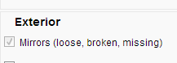

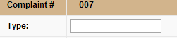

- In case of test_tech login page delete & check option not working Screen shot & link is given
Below :

http://www.acumencs.com/robus/admin/service/modify_information/TXpjallXTjE=

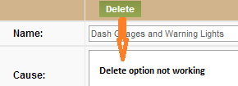

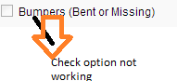

- In case of E-Series Van model year 2012 the underneath problem was happening in Lift gate type is missing but the name of the lift gate option was there. Screen shot & Link is given below :

http://www.acumencs.com/robus/admin/service/modify_information/TXpRallXTjE=

